**Admin Panel**

1. Login >>Add wrong password>> no error message—it should show an error message with email id filled.
2. My profile section>> there is no way to edit the profile section.
3. My profile section>> change password>> name of page is wrong>>currently it is edit profile it should be change password.
4. Change password>> leave new password and confirm password blank>> click add button>> change password is getting update.
5. Change password>> Instead of add button >> it should be update button.
6. Change password >> fill new password and leave the confirm password>> click on add button>> change password is getting update.
7. Change password>>Fill new password and add wrong password in confirm password>> click on add button—change password is getting update.
8. There is no way to edit the profile picture, company picture and profile name.
9. Through contact section I am able to edit the profile
10. Contact section—text labels missing as on my profile section

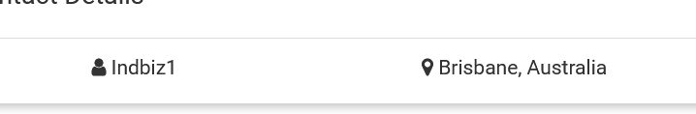

1. Edit contact>> phone number>> getting scroll which is not required
2. Edit contact>> phone number>> numeric validation missing
3. Edit contact>> able to edit email address which is wrong>> if it’s a requirement then a mail should be send and admin should logout.
4. Edit Contact>> leave username field blank>> no error message
5. More option >>left menu>> data protection>> not coming in same lines as other option’s

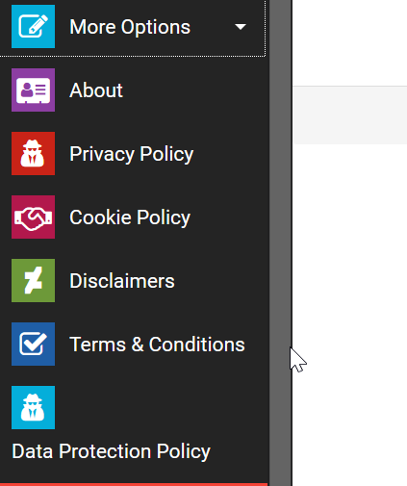

1. Listing>> export listing>>select car wash>>nothing is getting export.

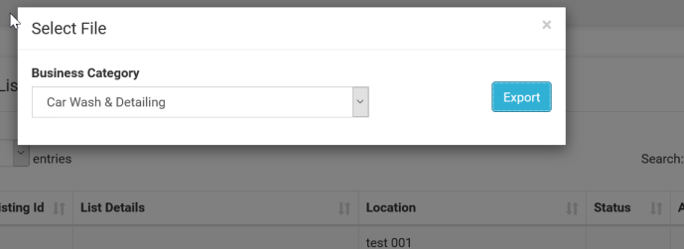

1. Listing>>copy listing>>spelling mistake of copy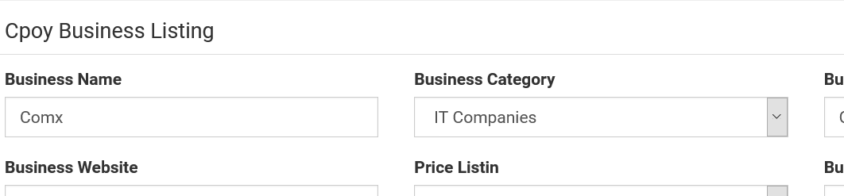
2. Edit Business listing>> spelling mistake of listing.

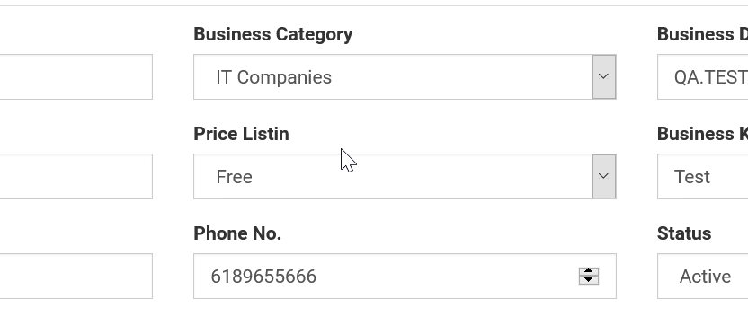

19. Edit business listing>> validation check missing from website url and phone number.

20. Edit Business listing>>able to enter start greater than end time.

21. Add Price/edit price>> Numeric /numeric length limit validation missing from price. 

22. Add Price>> leave any of the field blank and add price>> no error message

23. Add price>> No currency check is there when adding price.

24. Add state & city>>don’t fill any of the field and click on add >> no error message.

25. Add state & city>> I have marked “Queensland” as inactive but still getting when adding listing getting the Queensland as state

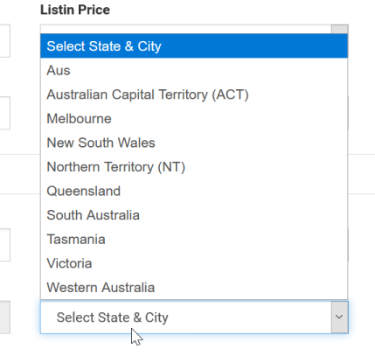

26. Category>> mark category as inactive but still getting when adding business listing and in website also.

27. category>> don’t fill any of the field and click on add >> no error message.

28. Category>> search any category>> filtered from text 27 distorted.

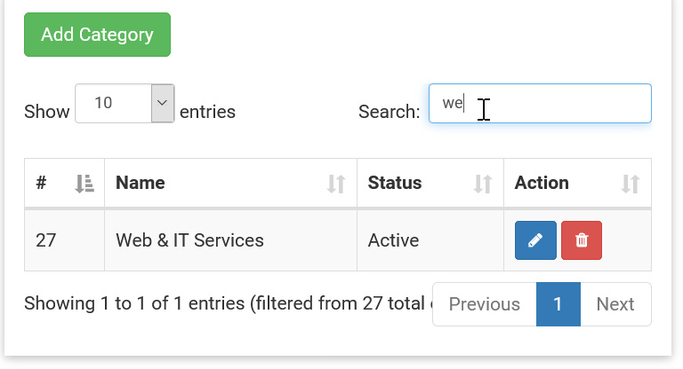

29. Category>>add sub category>> spelling mistake of category in” select category “ label

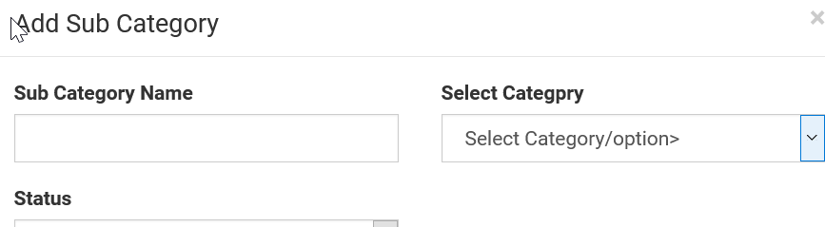

30. Category>>add sub category>>unwanted text under the select category

31. Category>> mark category as inactive but still getting when adding subcategory>> under select category drop down.

In homepage:

1. Trying to add your advertise business>>Advertised business should be displayed in Directory category and subcategory list. screen shots shows Advertise business is not displaying.

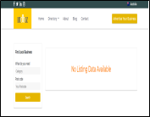

2.Homepage>>Click on facebook , Twitter, linkedin, Instagram links>>It should be going to the exact link.

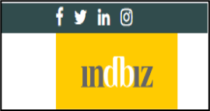

3.Homepage>>1.Click on advertise your business option, Enter all the details about the business and select the "listin price" field.>>pricing details and select the payment way should be here but screen shot shows as ”Here we have only the selection option”.

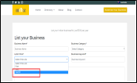

4.Homepage>>Contact us>>1.Select the Directory and select the category. Select the business and go to view listing, In contact us form enter the details and click on submit Message should be send particular contact and it should be display notification like (Message has been send).but screenshot shows it is going to contact us page.

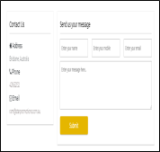

5.Homepage>>Search option>>Enter the name of category, Enter the invalid postcode. The expected result should not be display search list but it showing searched list.

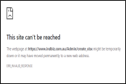

6. In website>>https-secured portal/domain needs to be enabled.

7.Australia-needs to be changed to specific state/suburb.

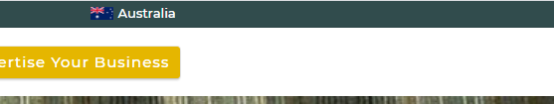

8.Enter Postcode>>when entered it gives e.g 4000 but shows results for possible 4000 strreet addresses across Australia.

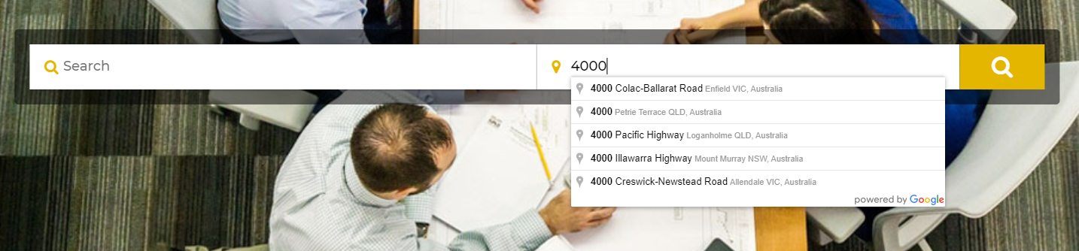

The site should be showing based on the Local IP Addresses or local area, business option here.

User should be able to change specifically if the need to search for other suburbs, state.coding should be take care for that.

9.In website link>>If we click on the Accommdation, rents it should not show listing6.. it needs to encrypted.

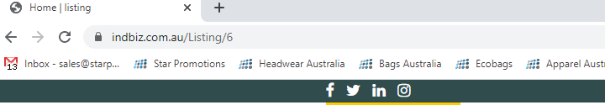

10.when new listing is added, the default option should be enabled for timings to show 9-5 Business days.

11.Home page>>Bottom of the side contact details>> click on social media links in Contact details in bottom of right side .the link are not working.



.